Change is Good Coin Campaign
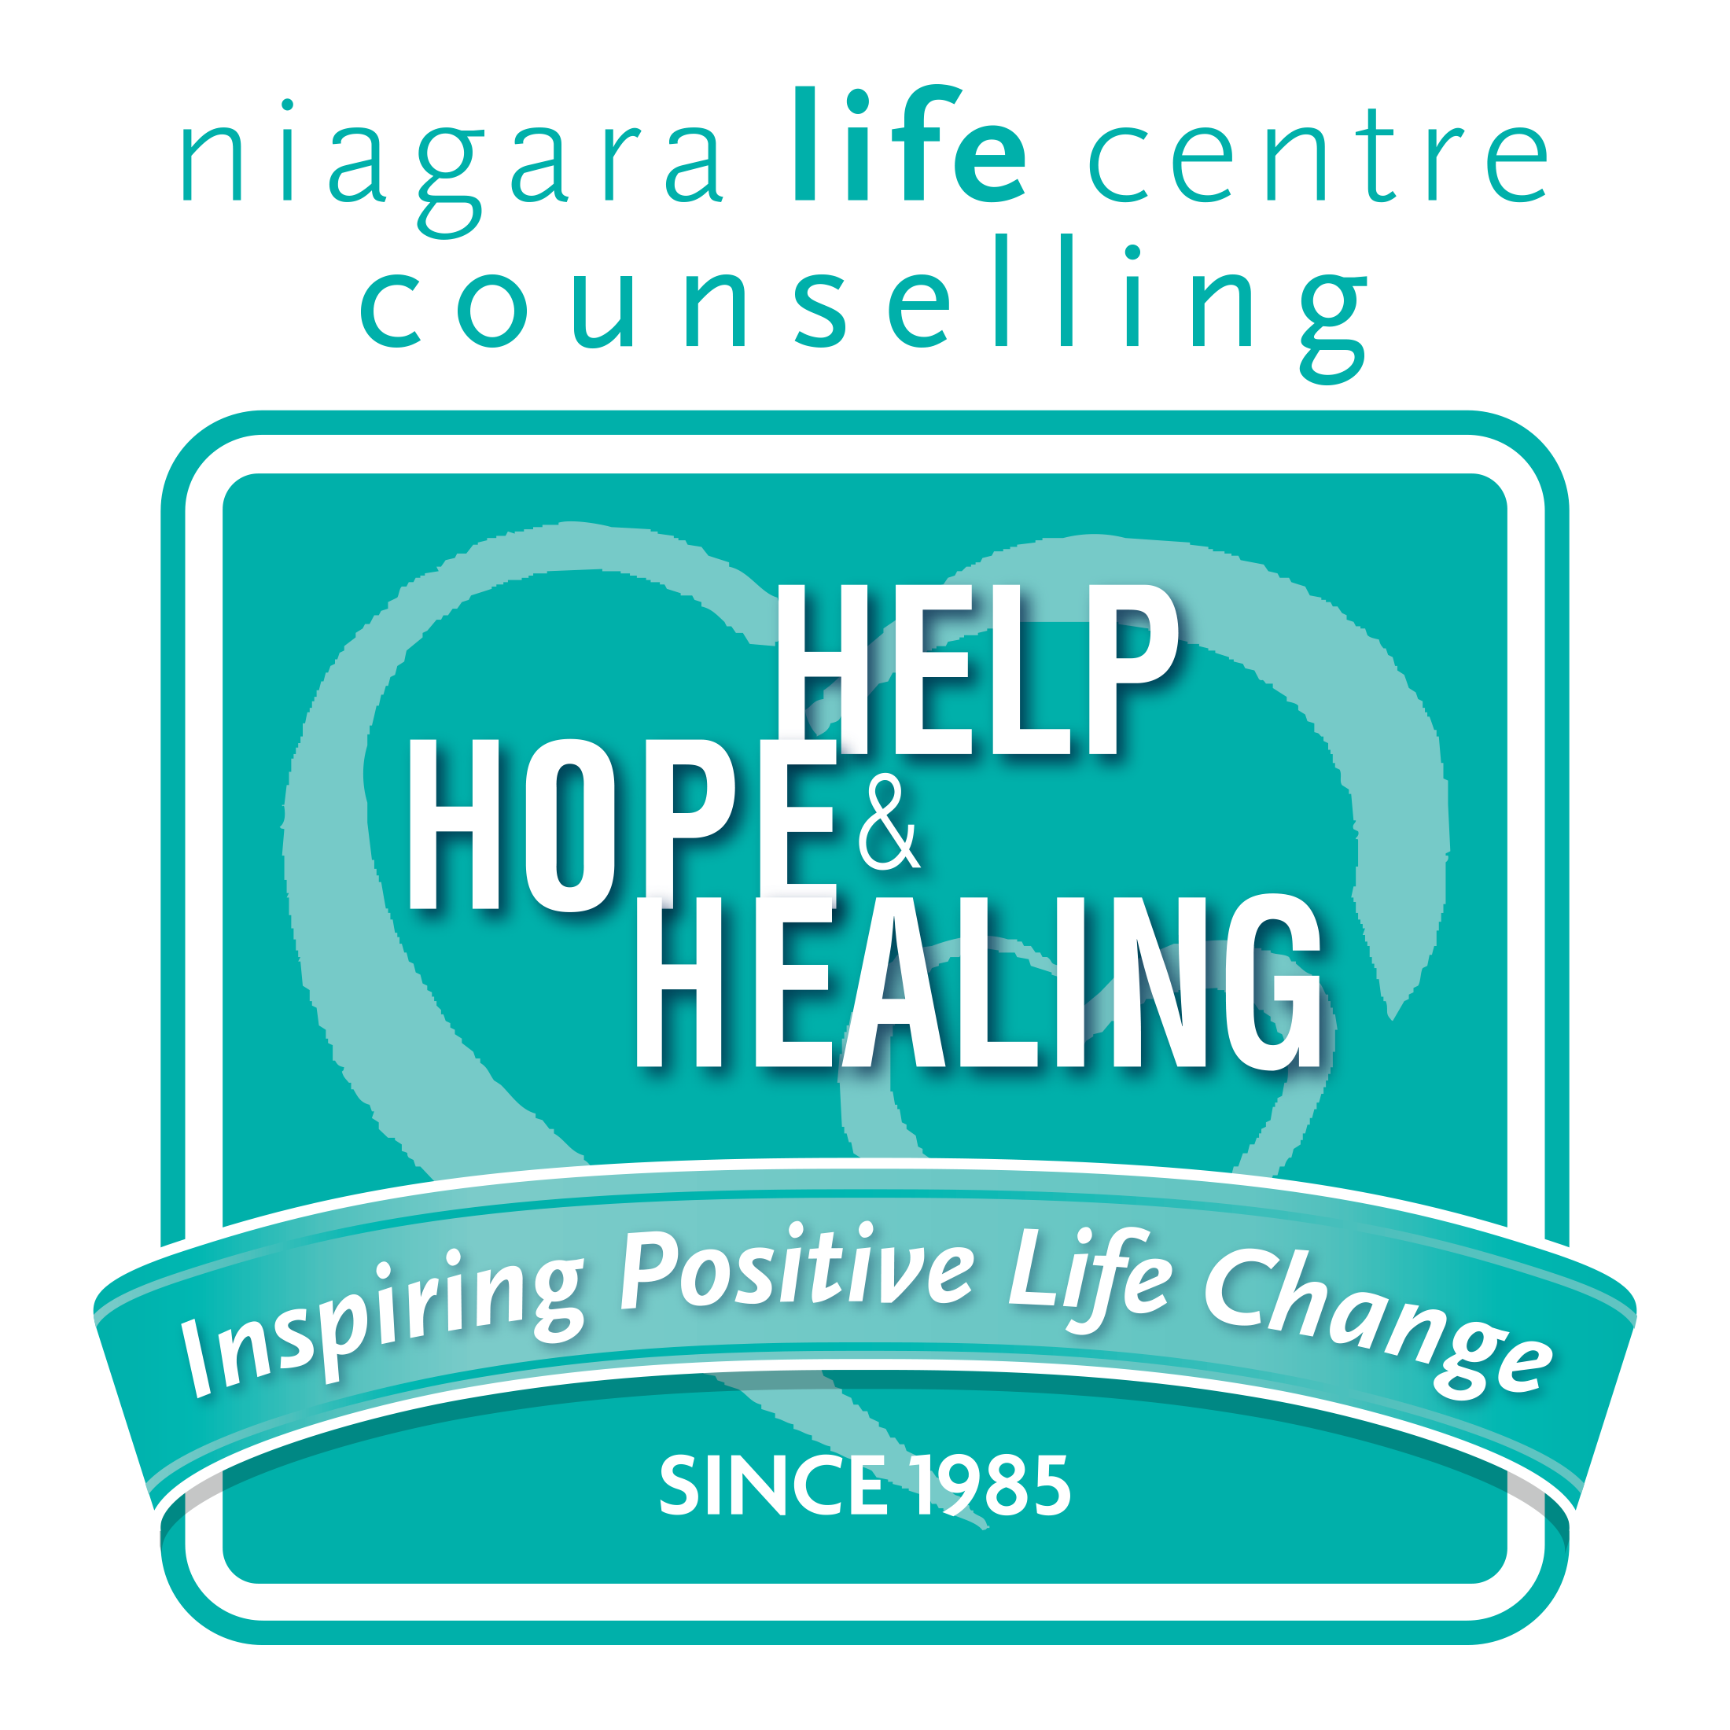
Spring 2017
Sample Bulletin Announcements

Announcement Prior to Distribution
On enter date we will be distributing coin collectors for Niagara Life Centre’s Change is Good Coin Campaign. Fill your container with spare change and support the life-changing programs at Niagara Life Centre. Containers will be collected on Father’s Day. More information is available at niagaralifecentre.ca/changeisgood or by calling 905-934-0021.
Announcement for Distribution Sunday
Please pick up your coin collector today for Niagara Life Centre’s Change is Good Coin Campaign. Fill your container with spare change and support the life-changing programs at Niagara Life Centre. Containers will be collected on INSERT DATE. NLC is a Christian-based counseling ministry, providing aid for individuals and families experiencing life crises. More information is available at niagaralifecentre.ca or by calling 905-934-0021.
Announcement for Weeks Between Distribution and Pickup
CONTAINERS STILL AVAILABLE! If you missed picking up a coin container
for Niagara Life Centre’s Change is Good Coin Campaign they can still be picked up in/from INSERT LOCATION OR PERSON HERE. Support the life-changing programs at Niagara Life Centre by filling your container with spare change. Please return your container on INSERT DATE. More information about NLC is available at niagaralifecentre.ca or by calling 905-934-0021.
Please continue to fill your containers to benefit Niagara Life Centre. Return the containers empty or full on INSERT DATE. Containers are still available and can be picked up INSERT LOCATION. Fill the containers with coins, cash or cheques as an offering to individuals and families experiencing life crises. Every dollar is appreciated and used wisely.

-Over-

ONE MORE WEEK: Please remember to fill your containers for Niagara Life Centre’s Change is Good Coin Campaign and return full or empty next Sunday. Cheques can be made out to Niagara Life Centre. NLC is a Christian-based counseling ministry, providing aid for individuals and families experiencing life crises. More information is available at niagaralifecentre.ca or by calling 905-934-0021.

Announcement for Collection Sunday
Thank you to all who participated in the Change is Good Coin Campaign in support of Niagara Life Centre. Please leave your containers INSERT COLLECTION POINT. Monies given will support the life-changing programs at NLC. Every dollar is appreciated and used wisely. Please prayerfully consider your ongoing support of this ministry. We rejoice to see how graciously God provides for needy individuals and families right here in your community. Thank you from Niagara Life Centre!

